TCP

Generally OSI Model has divided in to 7 Layers.
Application layer
Presentation Layer
Session Layer
Transport Layer
Network Layer
Data link Layer
Physical Layer

Port Is In Transport Layer, IP is in Network Layer, MAC is in Data Link Layer .
Why MAC and IP both ?
Because MAC is necessary when we communicate with other Routers.

  - Generally In Networking language bytes are called as octets(eight buts). TCP provides Relaible, Ordered, Error checked delivery of a sream of octets between applications running on the hosts communicating by an IP Network.
  - Relaible protocol means it provides Notification(ACK) to the sender whenever receiver receives data.
  - Not only Reliable protocol , it is also guarantee about sequence of packets.
  - Application program does not need to know the particular mechanisms for sending data via a link to another host, such as the required packet fragmentation on the transmission medium.
  - At the Transport Layer, the protocol handles all handshaking and transmission details and presents an abstraction of the network connection to the application.
  - network congestion, traffic load balancing, other un predictable network behaviour, IP Packets may be lost, duplicated or deliver out of order, TCP Detects & Corrects all these problems.
  - TCP is Responsible for Re transmission of lost data, Re arrange out of order data.
  - Once the TCP receiver has reassembled the sequence of octets originally transmitted, it passes them to the receiving application. Thus, TCP abstracts the application's communication from the underlying networking details.
  - TCP is optimized for accurate delivery rather than timely delivery and can incur relatively long delays (on the order of seconds) while waiting for out-of-order messages or re-transmissions of lost messages. Therefore, it is not particularly suitable for real-time applications such as Voice over IP.
  - Source port will be added in Transport Layer based on which application frames the packet.
  - Processes transmit data by calling on the TCP and passing buffers of data as arguments. The TCP packages the data from these buffers into segments and calls on the internet module [e.g. IP] to transmit each segment to the destination TCP.
  - TCP divides the data in to Segments.
  - In TCP Communication both Server and Client maintains Buffer to send or receive buffer.

TCP Does the Following things

Connection Establishment:

here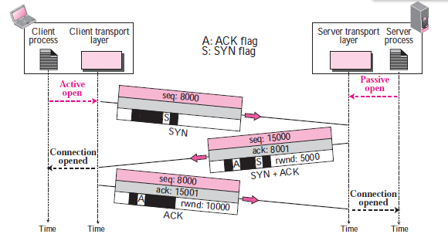

Here Final ACK doesn’t consume the Sequence number because it doesn’t carry data & to stay with the initial sequence number.

Connection Termination:

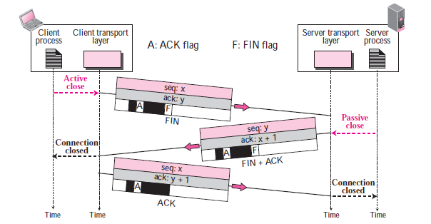

Asymmetric release(just hang-up) leads to loss of data.
Symmetric release
Treat Connection as two separate uni-directional connections.
Each Side Should be released separately.

Reliable transmission:
TCP uses a sequence number to identify each byte of data. The sequence number identifies the order of the bytes sent from each computer so that the data can be reconstructed in order.
Dupack based retransmission:

If a single packet (say packet 100) in a stream is lost, then the receiver cannot acknowledge packets above 100 because it uses cumulative acks. Hence the receiver acknowledges packet 101 again on the receipt of another data packet. This duplicate acknowledgement is used as a signal for packet loss. That is, if the sender receives three duplicate acknowledgements, it retransmits the last unacknowledged packet. A threshold of three is used because the network may reorder packets causing duplicate acknowledgements.

Timeout based retransmission:

The sender keeps a record of each packet it sends and maintains a timer from when the packet was sent. The sender re-transmits a packet if the timer expires before receiving the message acknowledgement.

Error detection:

Like check sum(16 bit).

Flow control:
To Maintain speed of data synchronization between client and server.

Pushing Data:
We know that TCP Uses buffer to store stream of data coming from the sending application program. The sending TCP can select the segment size. However, application program at the sender can request a Push operation. This means that sending TCP must not wait for the window to be filled. It should send data immediately.

Urgent Data:

There are occasions in which application program needs to send some urgent bytes, some bytes that need to be treated in special way by the application at the other end.
This 16-bit field, which is valid only if the urgent flag is set, is used when the segment contains urgent data. It defines a value that must be added to the sequence number to obtain the number of the last urgent byte in the data section of the segment.

What is Congestion?

Congestion in a network may occur if load on the network- the number of packets sent to the network is greater than the number of packets a network can handle.

When Congestion Occurs?

Congestion in a network or internetwork occurs because routers and switches have queues and buffers that hold the packets before and after processing. The packet is put in appropriate output queue and waits its turn to be sent. These queues are finite, so it is possible for more packets arrive at a router than the router can buffer.

Congestion Control:

Congestion Control refers to mechanisms and techniques to control the congestion and keep the load below capacity.

Open-Loop Congestion Control:

In this policies are applied to prevent congestion before it happens. In these mechanisms, congestion control is handled by either the source or the destination.

Retransmission Policy:

Retransmission is sometimes unavoidable. If the sender feels that a sent packet is lost or corrupted, the packet needs to be retransmitted. Retransmission in general may increase congestion in the network. However a good retransmission policy can prevent congestion. The retransmission policy and retransmission timers must be designed to optimize the efficiency and at the same time prevent congestion.

Window Policy:

The type of the window at the sender may also affect congestion. Selective Repeat window is better than Go-Back-N window for congestion control.

Acknowledgement Policy:

The acknowledgement policy imposed by the receiver may also affect congestion. If
the receiver does not acknowledge every packet it receives, it may slow down the
Sender and help prevent congestion. Several approaches are used in this case.
A receiver may send an acknowledgment only if it has a packet to be sent or a
special timer expires. A receiver may decide to acknowledge only N packets at time.
We need to know that the acknowledgments are also part of the load in a network.
Sending fewer acknowledgments means imposing less load on the network.

Closed-Loop Congestion Control:

Closed-loop congestion control mechanisms try to alleviate congestion after it happens. The size of the window at the sender size can be flexible. One factor The size of the window at the sender size can be flexible. One factor that can determine the sender window size is the congestion in the Internet. The sending transport layer can monitor in the Internet, by watching the lost packets, and use a strategy to decrease the window size if the congestion is increasing and vice versa.

tcp connection is made as follows:
1) sender and receiver synchronizes so that a connection is made. The OS in both the end are informed that a conenction is established.
2) then sender starts transmitting data. it also gets acknowledgements. a timer is started as soon as the sender starts sending data.
3) if the sender has not received any ack even after the timer exceeds it limit, then it retransmits data.
4) in case of windowing,if the buffer on the receiver is full, the receiver sends a stop signal to the sender. the sender stops transmitting data.
5) then after processing all data, the receiver sends a go signal to the sender. then, the sender starts transmitting data again. this is in case of windowing.

